February 10, 2017:

[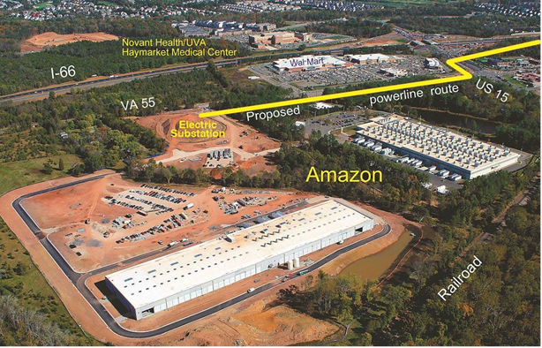](http://www.insidenova.com/content/tncms/live/#1)

August 2015:

[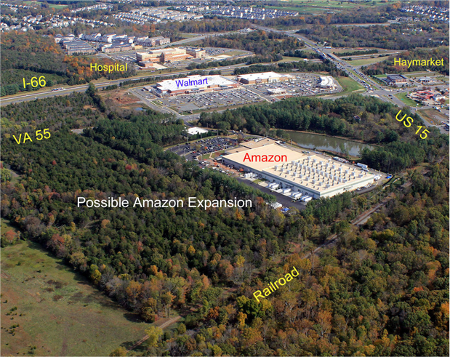](http://www.insidenova.com/content/tncms/live/#1)