Prince William vows to fight SCC over power line route
by Uriah Kiser on June 6, 2017 at 12:52 pm
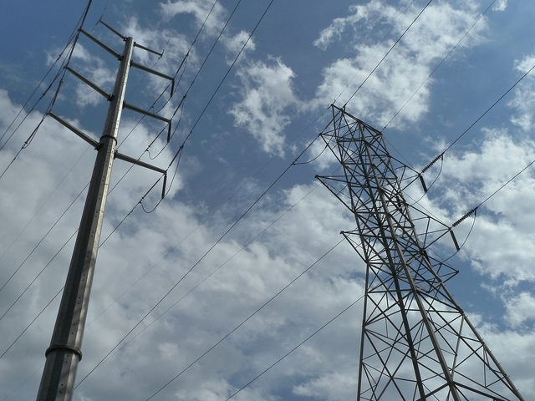
The Prince William County Board of Supervisors voted 7-0 to reaffirm its support of the overhead and underground hybrid route plan for a new power line in Haymarket.
The I-66 Hybrid Alternative route would build the 234,000 volts, 10-mile power line overhead, connecting with an existing line near the intersection of Route 234 and Interstate 66. The line would then run underground near homes along I-66 until it makes its connection to a power substation near a Walmart in Haymarket.
The Board aims to block the construction of an overhead power line that along one of two routes favored by the State Corporation Commission (SCC): Along the Carver Road route, or along the railroad line route in Haymarket.
County residents at a special June 1 meeting of the Board of Supervisors urged officials to block attempts to build along either of these two routes favored by the SCC. They said it would adversely affect property values in neighborhoods along the routes like Hopewell’s Landing, Somerset, and Greenhill crossings.
“We’re going to fight this tooth and nail. Our job is to protect you and your property this fight has just begun. We’re not going to let Dominion or the SCC divide us, and we’re going to win,” said Board Chairman Corey Stewart, At-large.
Potomac District Supervisor Maureen Caddigan was absent from the meeting on a family vacation in Europe.
The SCC released its findings and noted its support for the Carver or Railroad routes in April. Prince William officials had 60 days to respond and did so by sending this letter to Dominion Energy.
The data center is said to be owned and operated by Amazon, Inc.
Does the data center need all that electricity to start with?
The Supervisors directed county staff to find more information, including a transcript of a public meeting held in March with Dominion, The Army Corps of Engineers, and VA Data, an entity working for Amazon handling the regulatory affairs work for construction of the data center. Dominion was at the meeting as an interested observer and did not speak, according to a spokesman for the utility.
At that meeting, Robert Weir, of Haymarket and member of the Protect Prince William Coalition, a group that opposes a new overhead power line, learned that only the third of three planned data centers buildings for the site would need the electricity from the new power line, he said. The first two buildings — one of which is already built — could operate off the existing power grid, he said.
Weir met with Stewart before the June 1 meeting to discuss the revelation. An attorney from VA Data who spoke at that March meeting held in Fredericksburg revealed that information, according to Weir.
“Did Amazon misrepresent their power needs to dominion? Did Dominion overstate the power needs of Amazon,” asked Weir.
“This was originally pitched to the community that we need the power line or lights will go out in Haymarket and Gainesville,” said Gainesville District Supervisor Peter Candland. “That was quickly disproven.”
The utility maintains the need for the power line has not changed.
“The SCC verified that the line is necessary and determined that it is in the public interest” stated Dominion spokesman Chuck Penn in an email to Potomac Local. “Moreover, the Commission found that the transmission line would have broad community benefit on day one of it being put into service. It will service more than 450 customers, including those in an important commercial center and a medical center — in addition to resulting in greater reliability for all customers in the Haymarket area. This will allow for much shorter restoration times when there are outages.”
Historic preservation group says center adversely impacts nearby battlefield
The Advisory Council on Historic Preservation also weighed in on the matter and urged the Corps of Engineers to review the data center site. They say all 35 acres of the planned site has been cleared for construction of the second and third buildings, which were not discussed as part of Amazon’s original plans.
That has had an adverse affect on the nearby Buckland Mill Civil War Battlefield. The group called for a federal review.
“If there is any documented evidence that Amazon knew that historic properties were in that area and they proceeded to clear the site to construct buildings, that shows intent, from our perspective,” said Charlene Dwin Vaughn, with the preservation council.

